Buffalo Lake 2023

Buffalo Lake gives special THANKS to Bill Lind.

On May 26th, 2023 the Buffalo Lake Fish Committee held a fish stocking event in memory of Bill Lind.
Bill Lind the owner of Holiday Shopping Center passed away late last year. Bill was a founding member of the fish committee and a huge contributor towards everything on Buffalo Lake.
His daughter, Rhonda Hughs was present in appreciation of the recognition.
Rhonda operates Holliday Shopping Center.
Wisconsin Senator Ballweg and Wisconsin Representative Plumer were also
on hand in support of Buffalo Lake and Bill Lind.
Over 3,700 fish were stocked, 2,550 perch, 450 bass, 780 crappie.
The following area businesses support Buffalo Lake by contributing to an annual advertising fund used to stock the lake with fish. Everyone can show their support by patronizing these businesses -- and be sure to mention your appreciation.
Area Businesses include:
Northside Auto | Weezie's Town Pump | Walker Agency | 'Tween the Lakes Hotel | Rendezvous | Piers Plus | Kathleen's Flour Bin | Johnson's Boats & Motors | Holliday Shopping Center | Hoffmann Tree Service | Cotter Realty | Buffalo Lake Camping Resort / Wisconsin Lake & Pond Resource

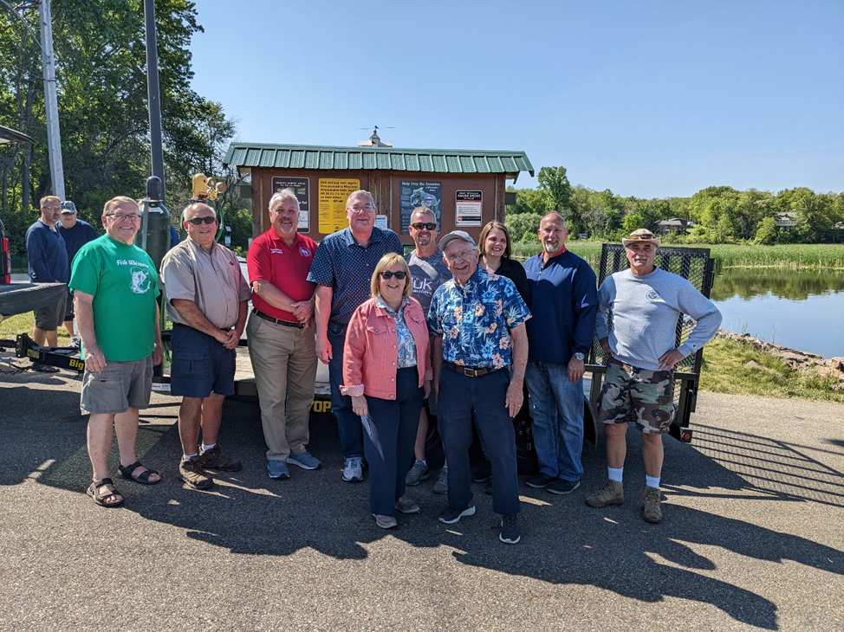
Back row: William Faulkner Tween the Lakes Hotel, Gary Doudi Buffalo Lake Campground & Fish Committee Co-Chair, State Rep Plumer, Paul Ratzburg Fish Committee Co-Chair,
Bernie Sosinsky District Chair, Rhonda Hughs Holliday Shopping Center, Randy Polk Walker Insurance, Dan Braaksma Fish Committee
Front row: Wi State Senator Ballweg, Al Rosenthal Marquette Co Board Vice Chair

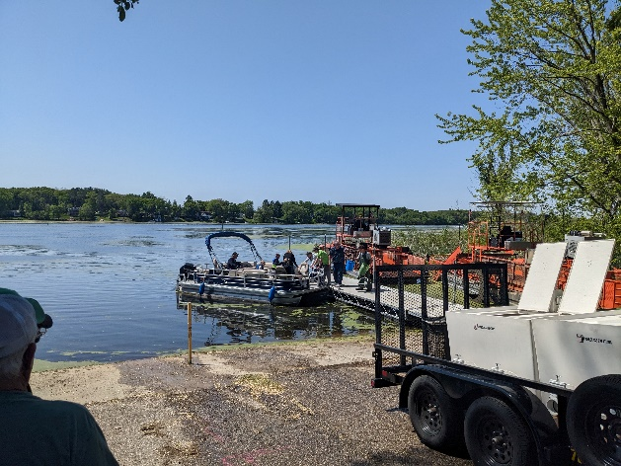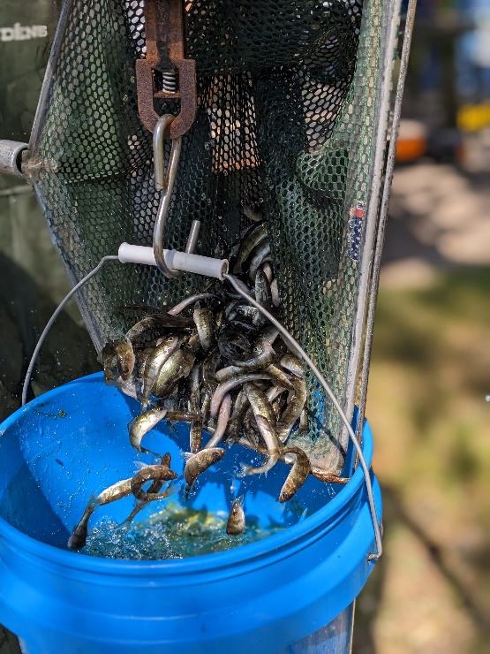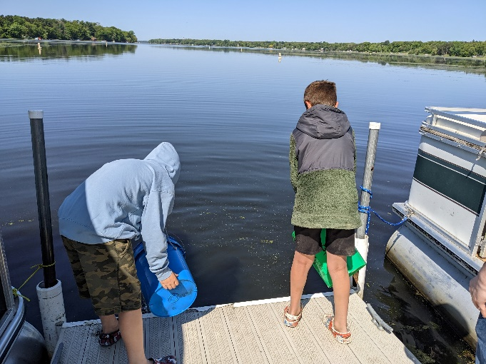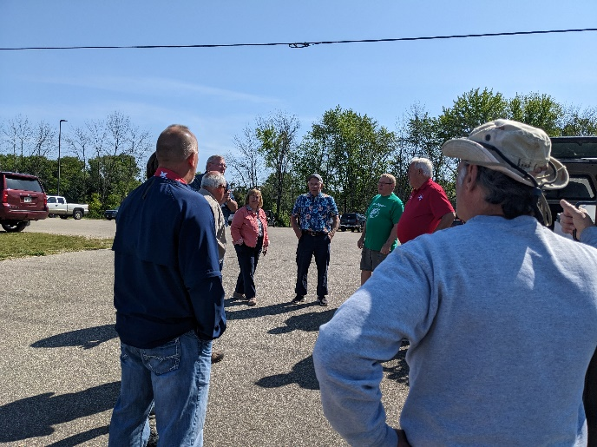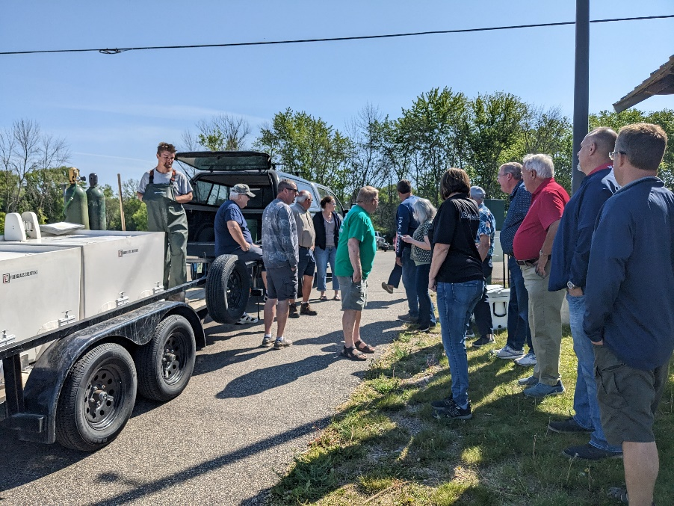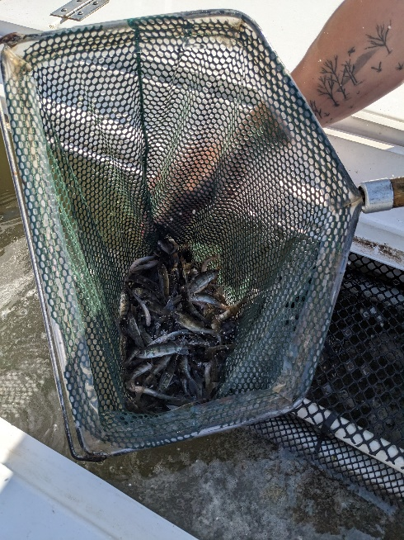
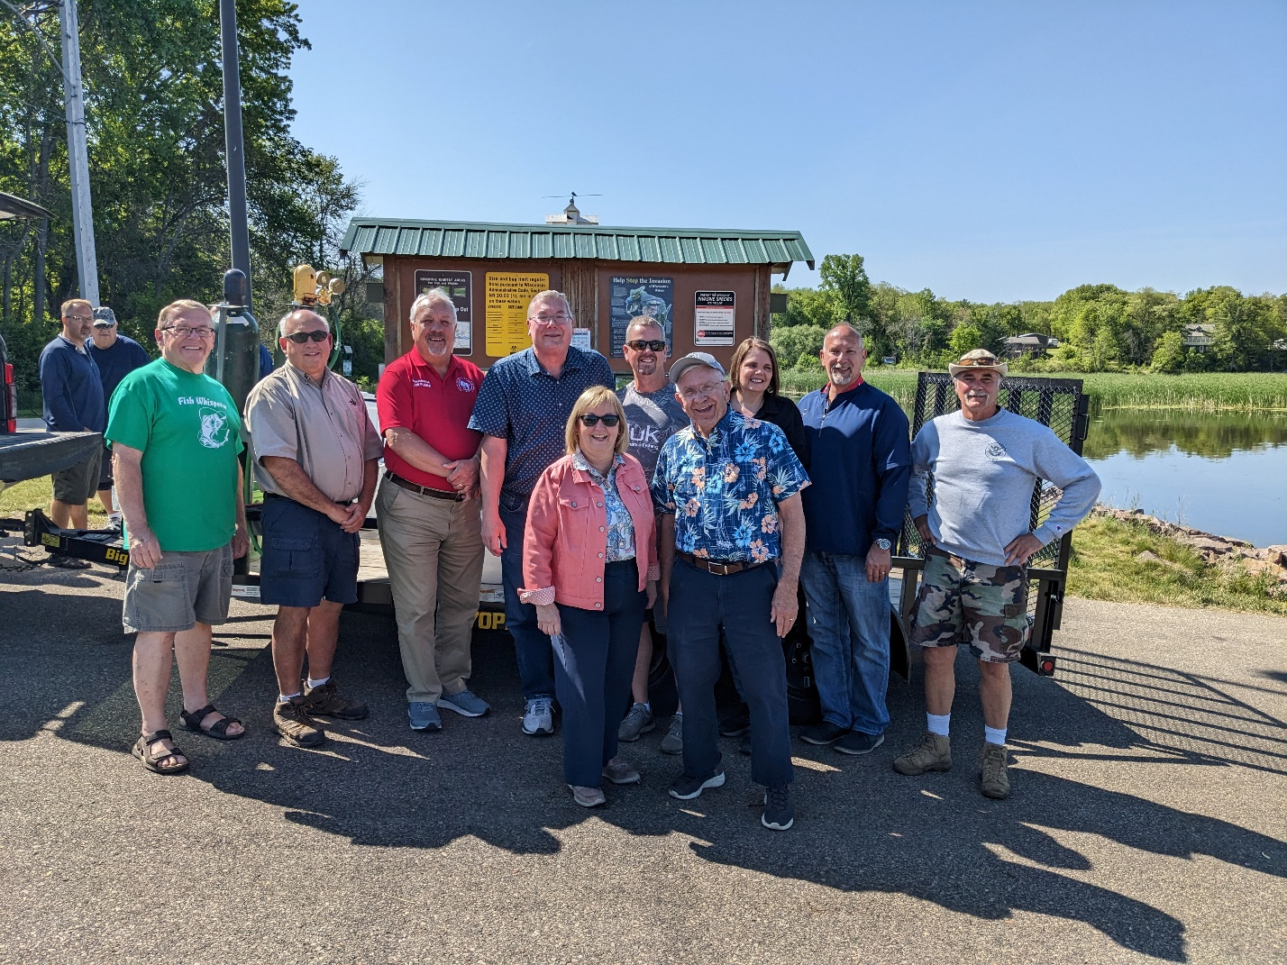
Back row: William Faulkner Tween the Lakes Hotel, Gary Doudi Buffalo Lake Campground & Fish Committee Co-Chair, State Rep Plumer, Paul Ratzburg Fish Committee Co-Chair,
Bernie Sosinsky District Chair, Rhonda Hughs Holliday Shopping Center, Randy Polk Walker Insurance, Dan Braaksma Fish Committee
Front row: Wi State Senator Ballweg, Al Rosenthal Marquette Co Board Vice Chair

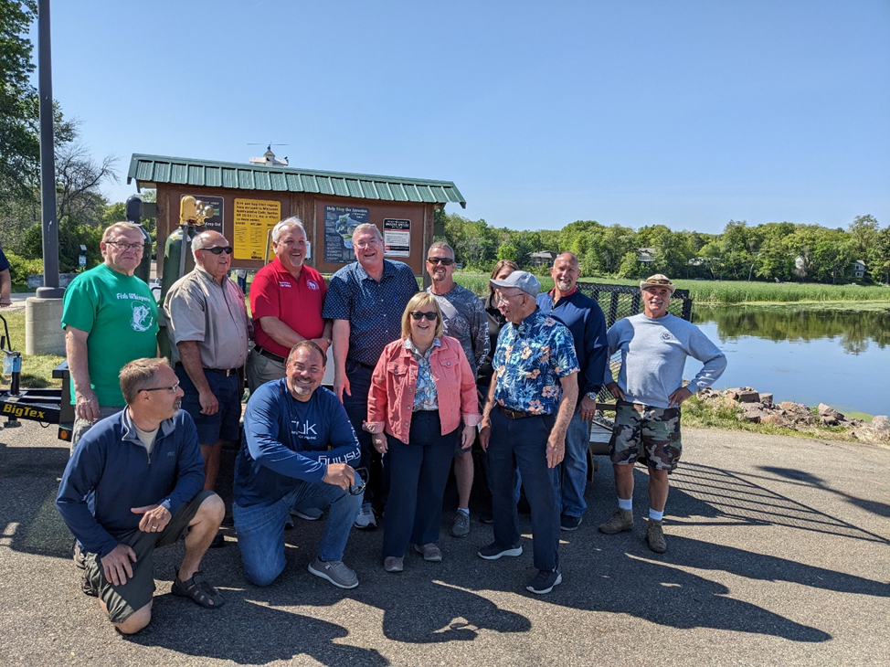

Back row: William Faulkner Tween the Lakes Hotel, Gary Doudi Buffalo Lake Campground & Fish Committee Co-Chair, State Rep Plumer, Paul Ratzburg Fish Committee Co-Chair,
Bernie Sosinsky District Chair, Rhonda Hughs Holliday Shopping Center, Randy Polk Walker Insurance, Dan Braaksma Fish Committee
Front row: Doug Searles, Jim Felt, Wi State Senator Ballweg, Al Rosenthal Marquette Co Board Vice Chair

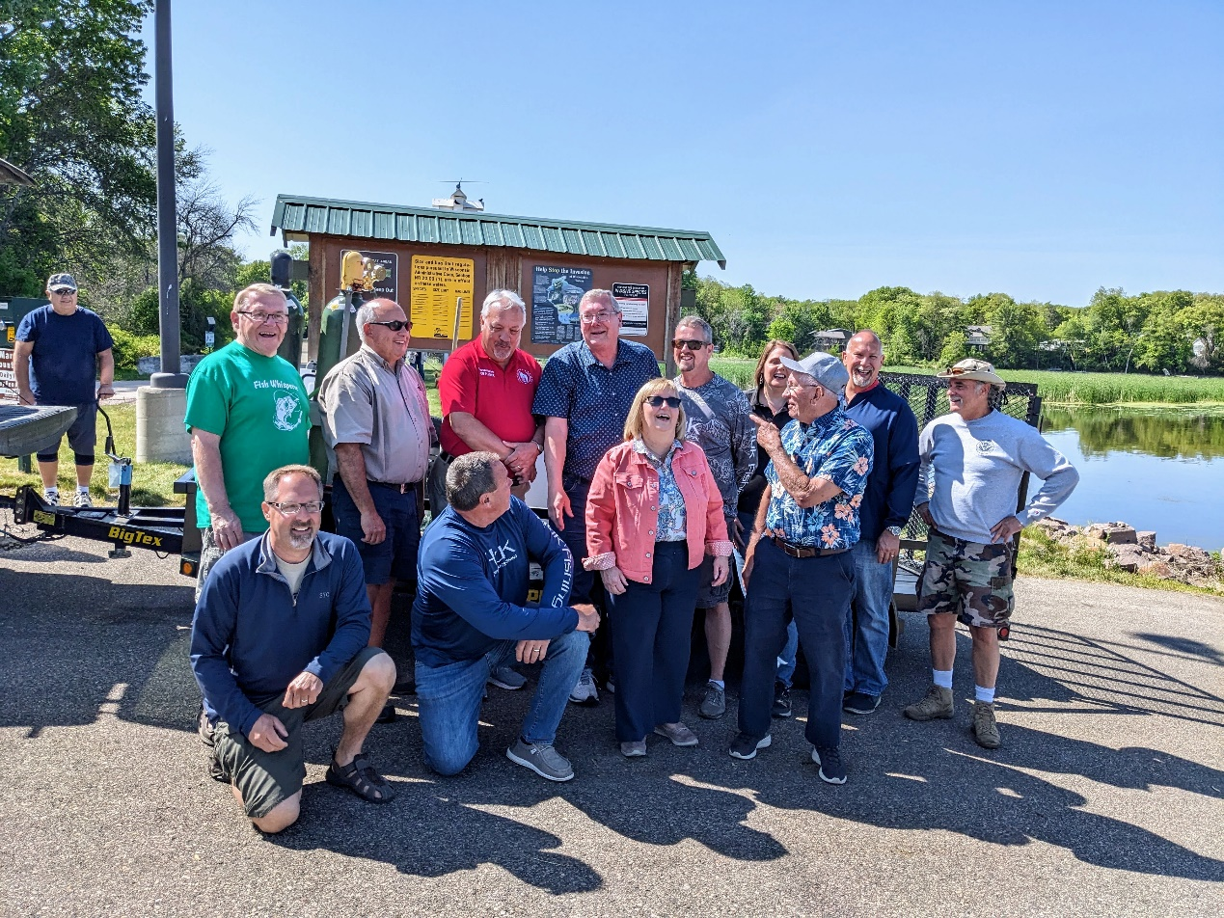
Back row: William Faulkner Tween the Lakes Hotel, Gary Doudi Buffalo Lake Campground & Fish Committee Co-Chair, State Rep Plumer, Paul Ratzburg Fish Committee Co-Chair,
Bernie Sosinsky District Chair, Rhonda Hughs Holliday Shopping Center, Randy Polk Walker Insurance, Dan Braaksma Fish Committee
Front row: Doug Searles, Jim Felt, Wi State Senator Ballweg, Al Rosenthal Marquette Co Board Vice Chair

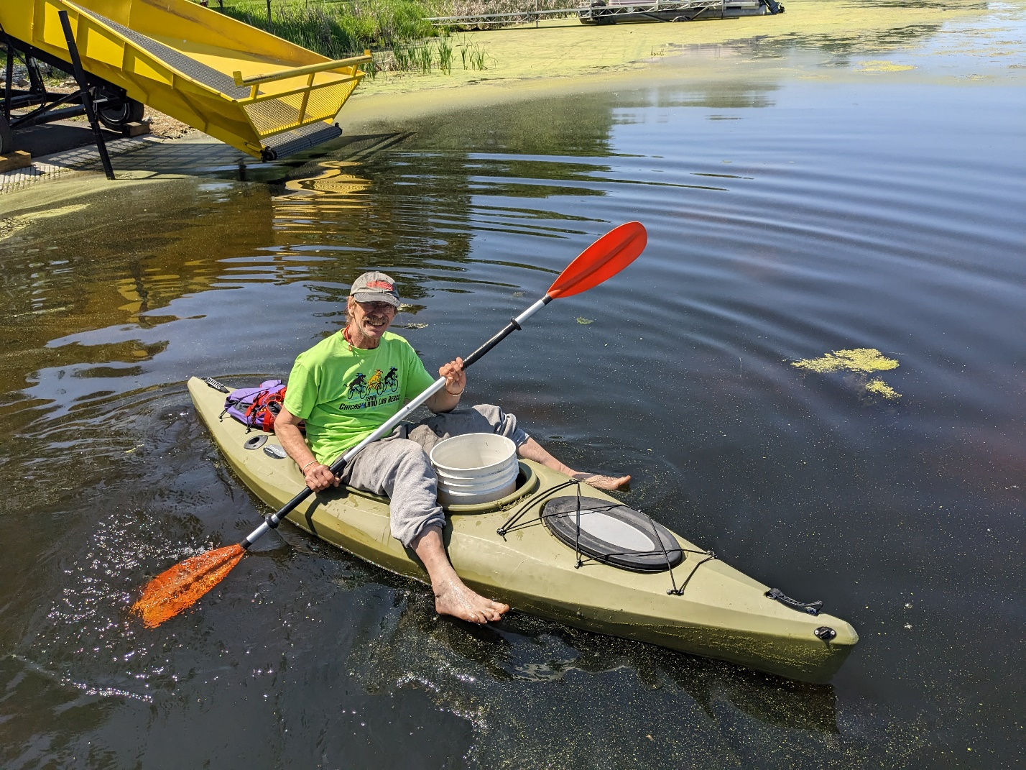
Freedom Landing: Clark Adams
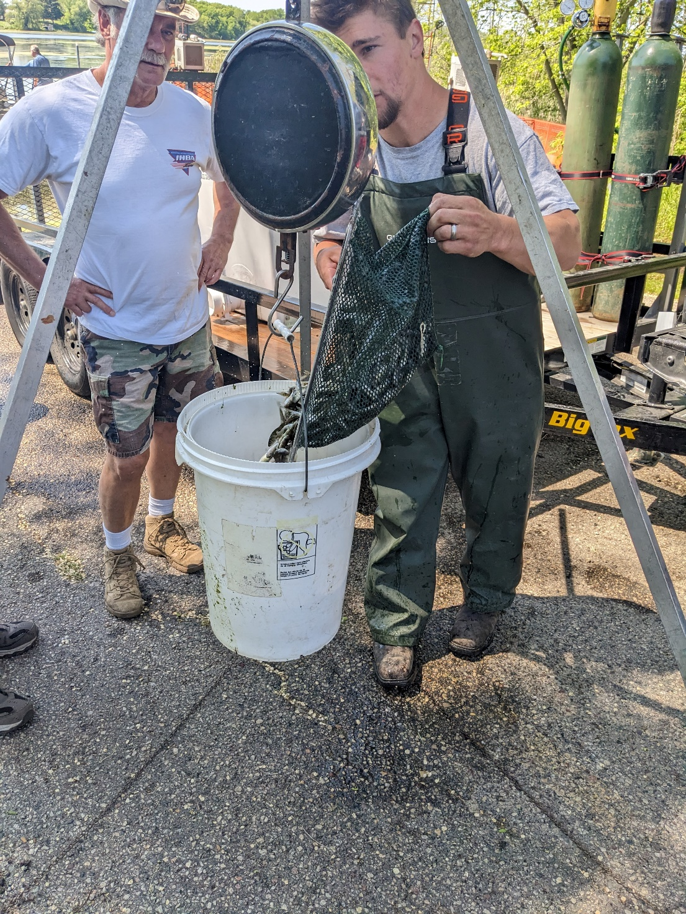
Dan Braaksma, Drake Schachtner
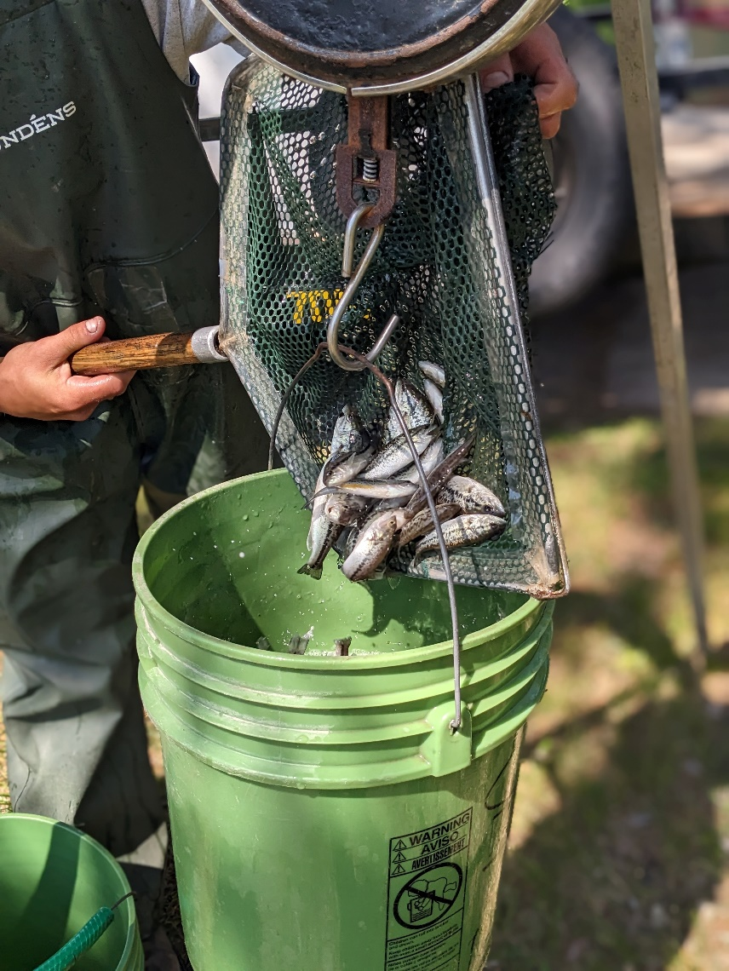
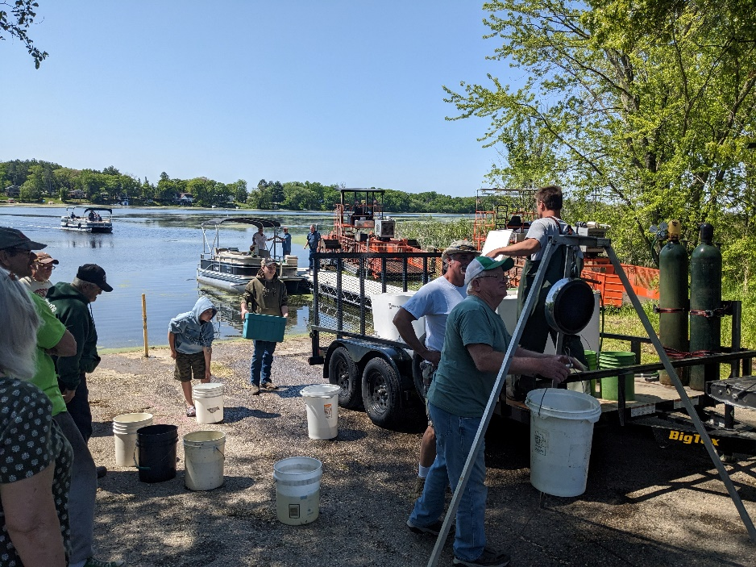

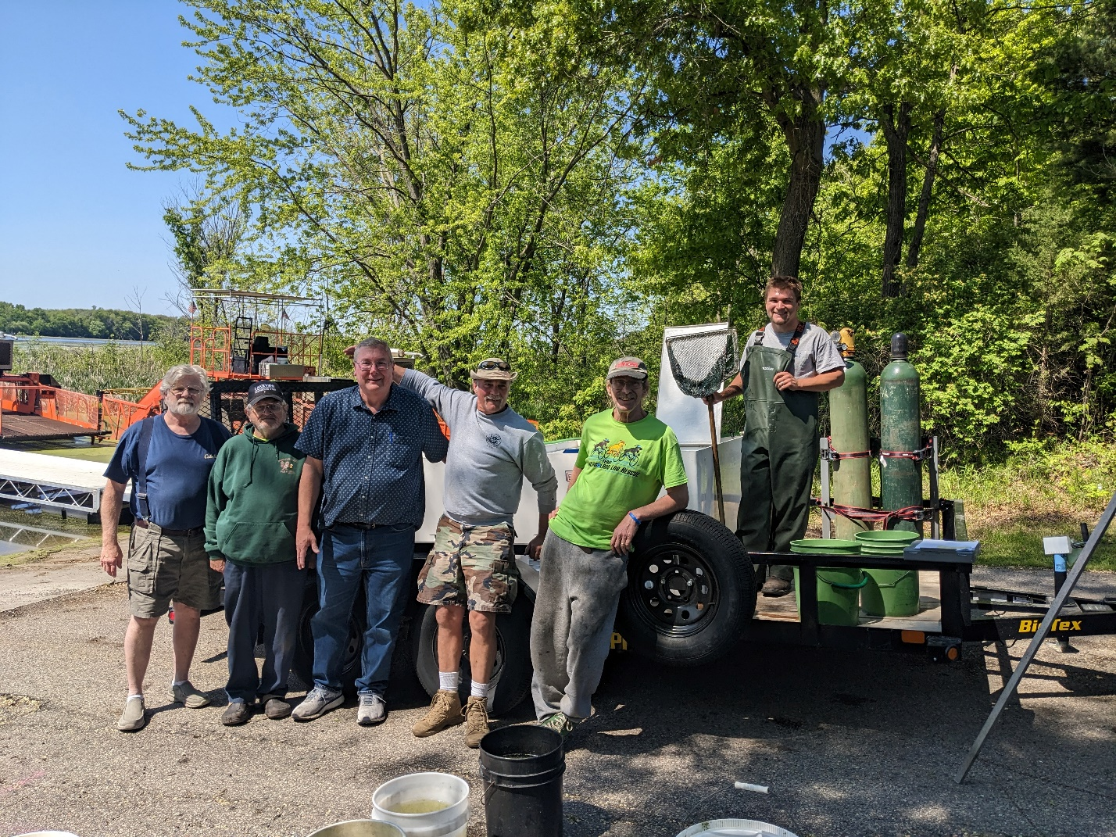
CTH C Landing: Larry Haygood, Frank Behling, Paul Ratzburg, Dan Braaksma, Clark Adams, Drake Schachtner
CTH C Landing: Larry Haygood, Frank Behling, Paul Ratzburg, Dan Braaksma, Clark Adams, Drake Schachtner

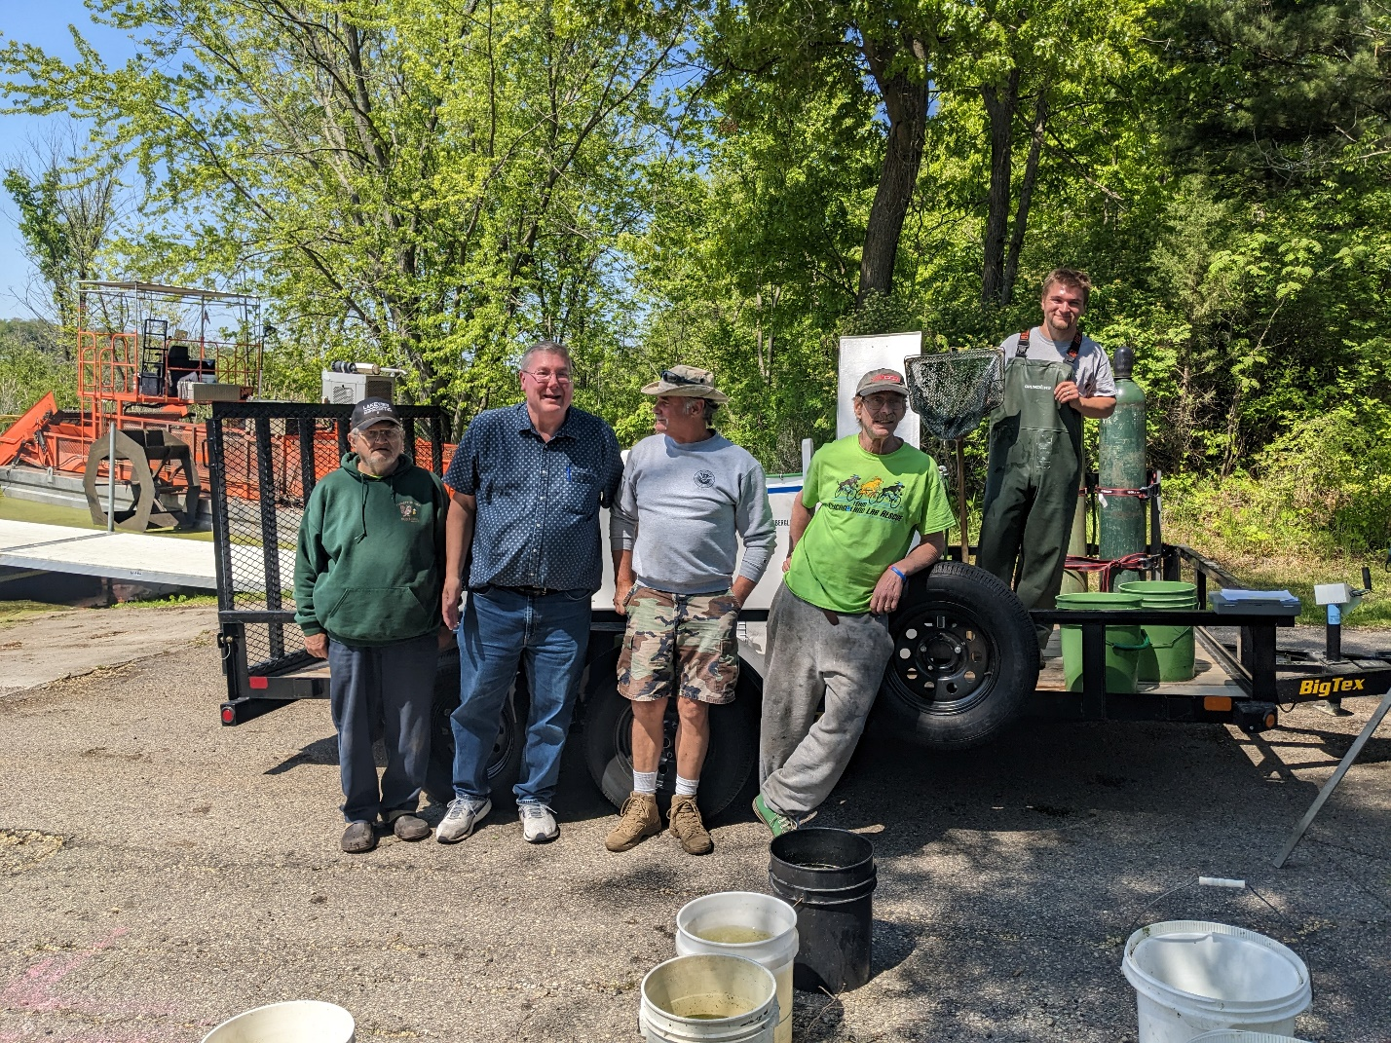
CTH C Landing: Frank Behling, Paul Ratzburg, Dan Braaksma, Clark Adams, Drake Schachtner

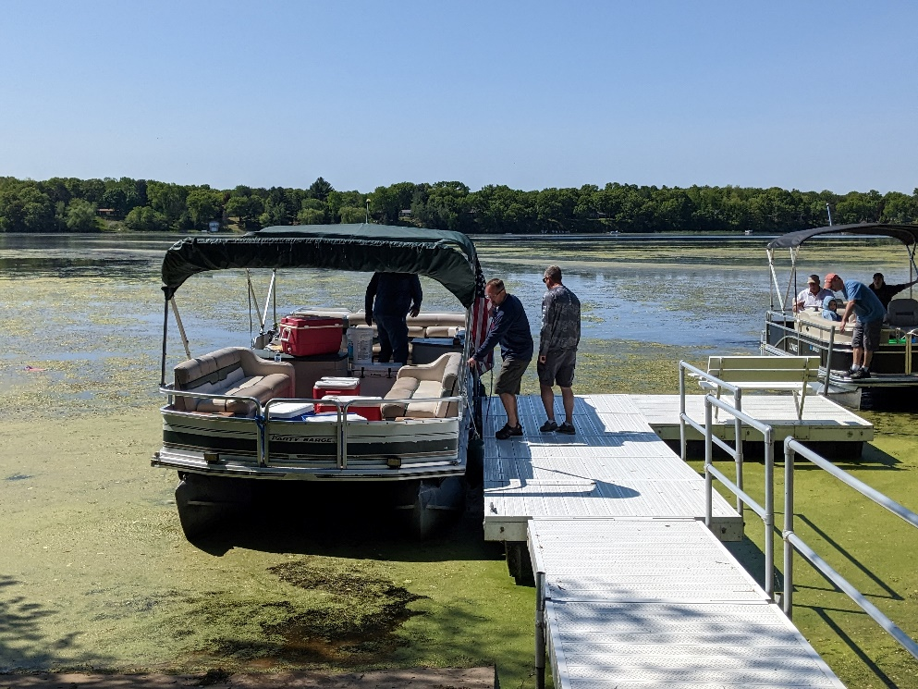
Jim Felt, Doug & Bernie
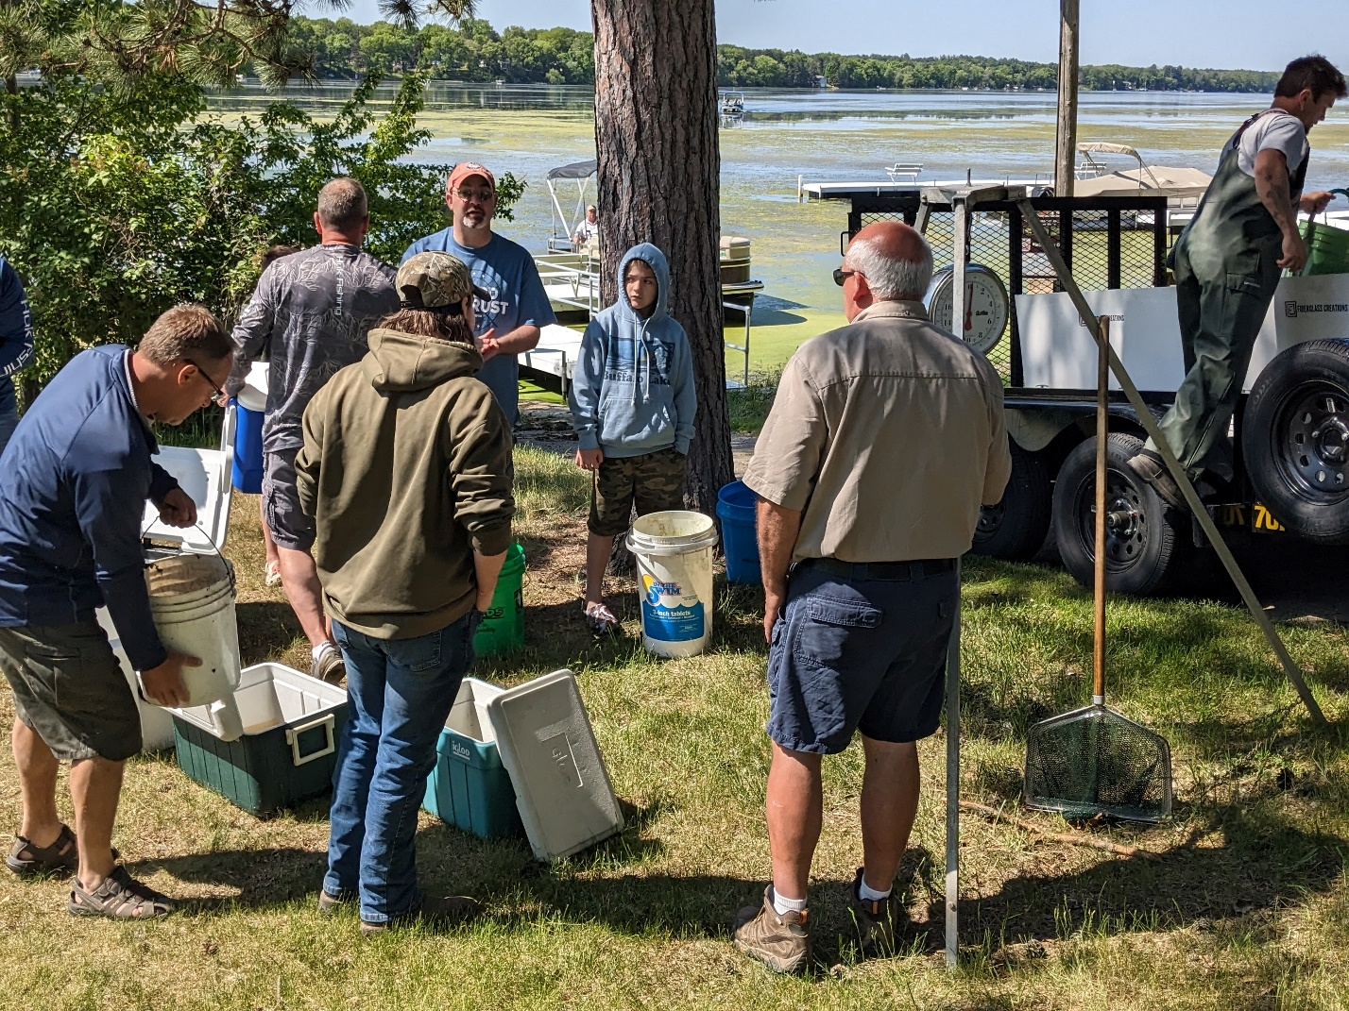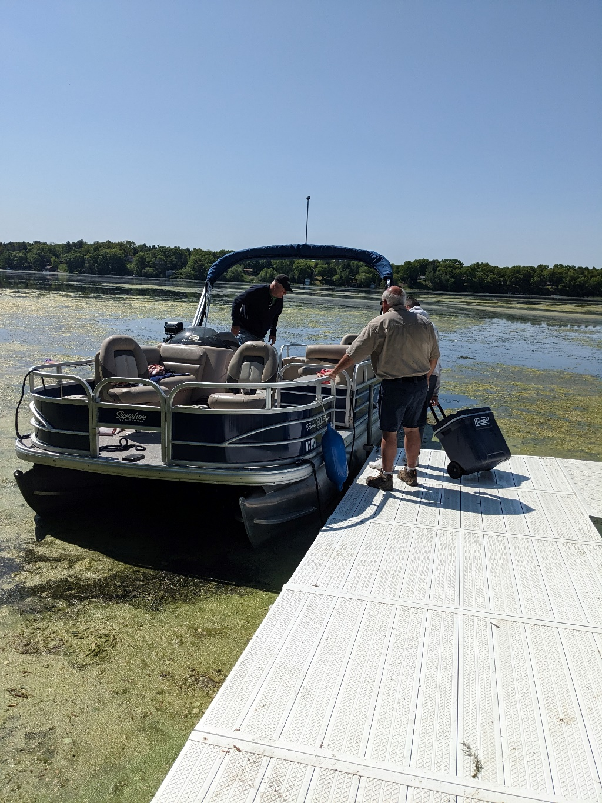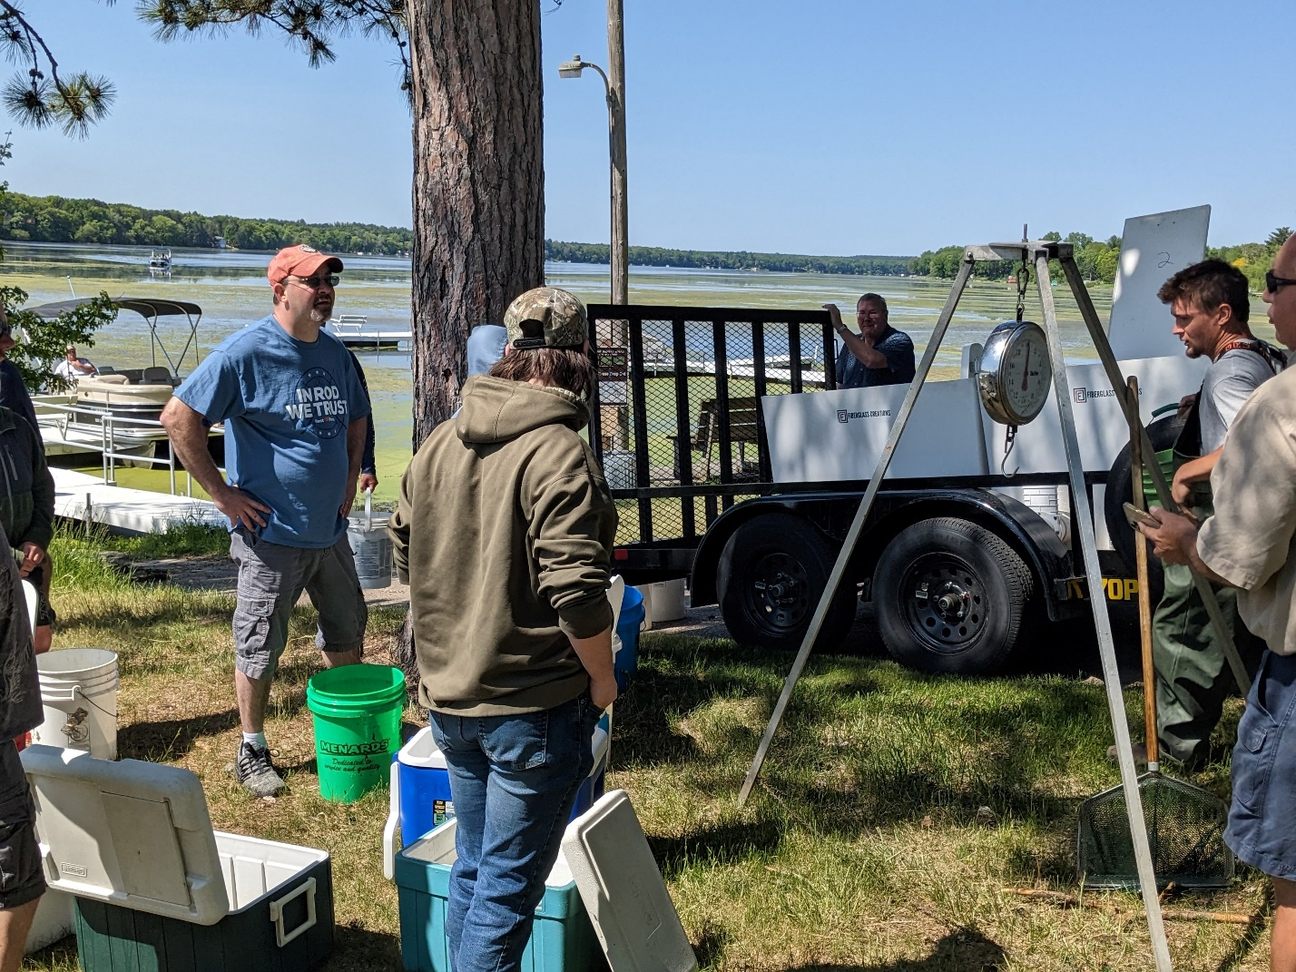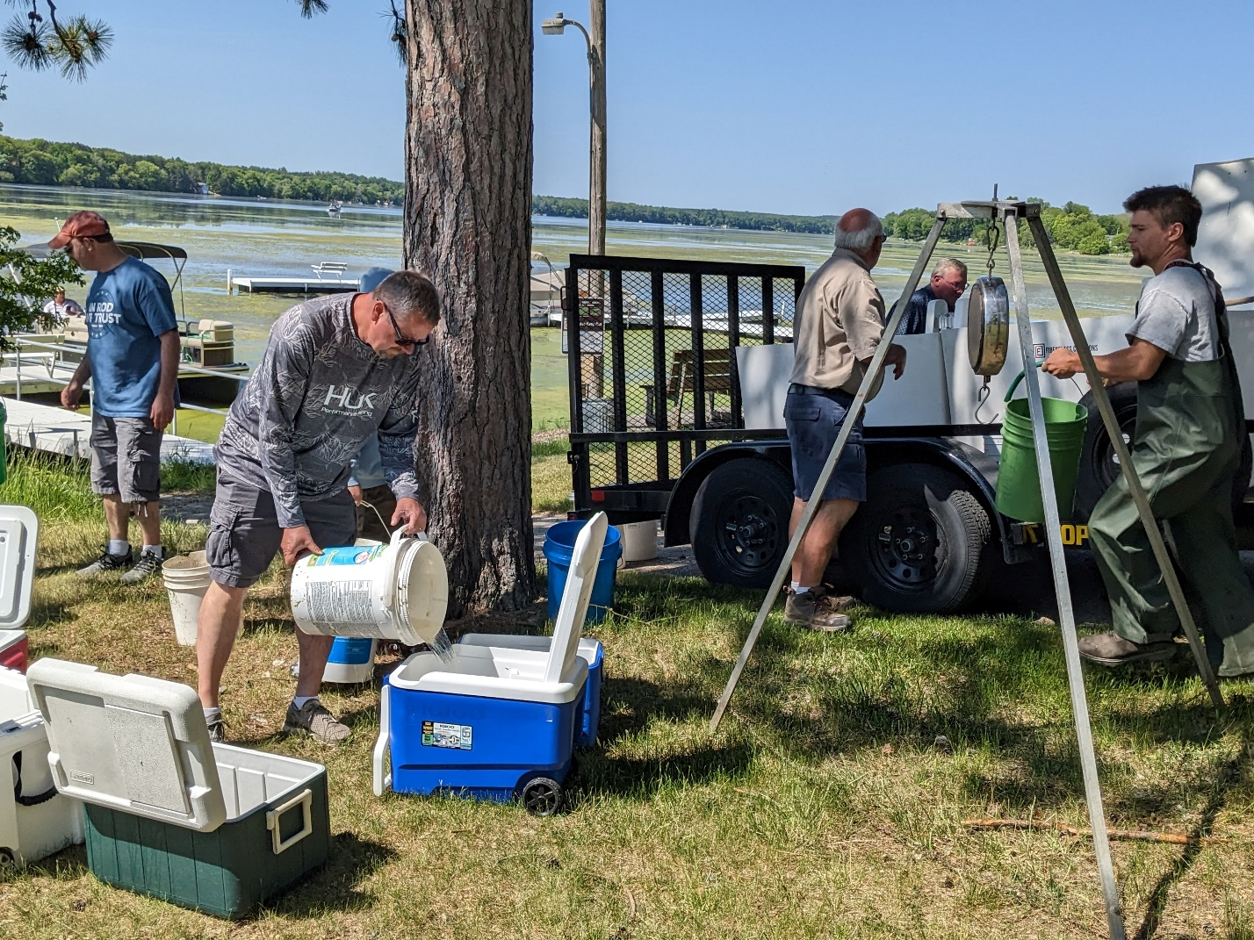
Bernie Sosinsky filling coolers with fish
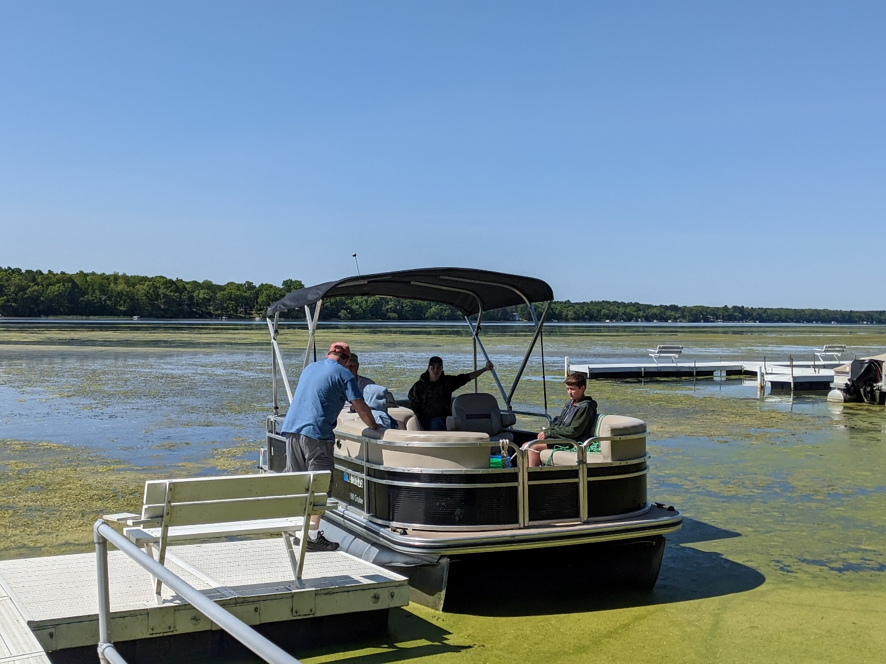
Calvin Wood Family
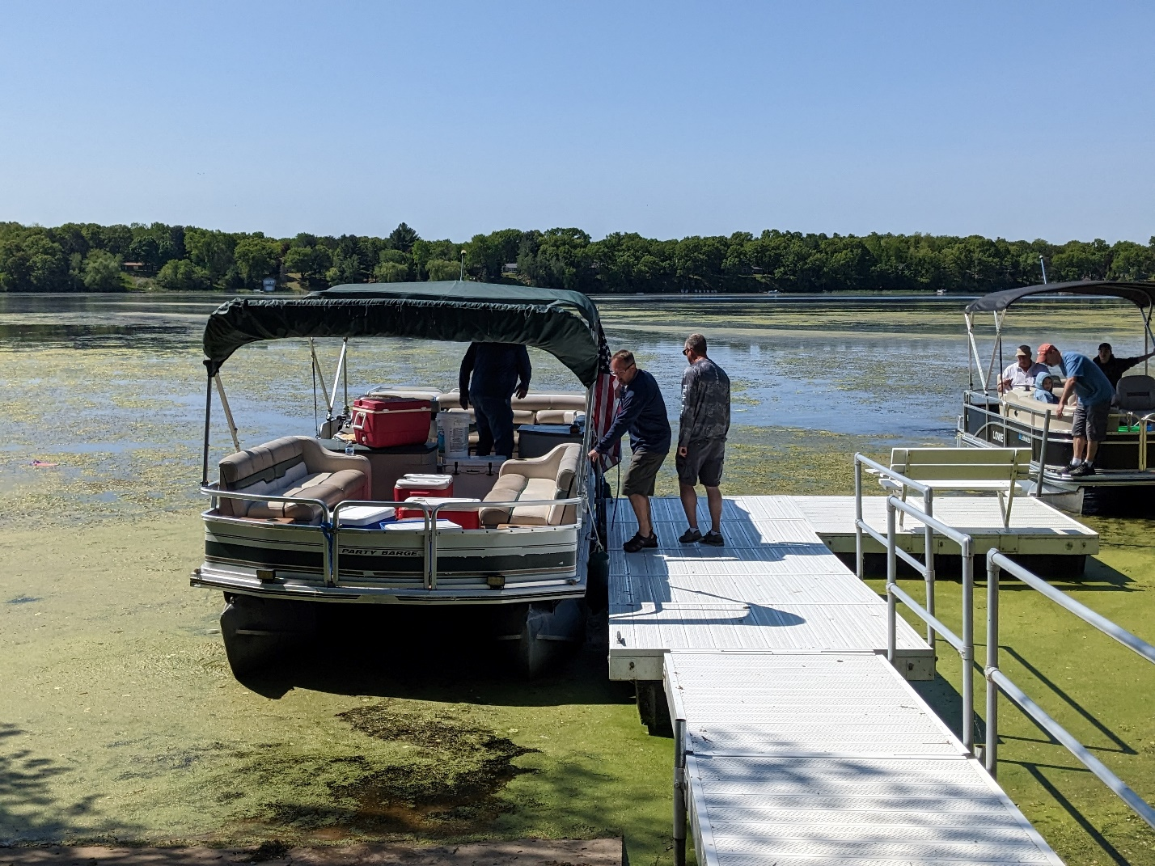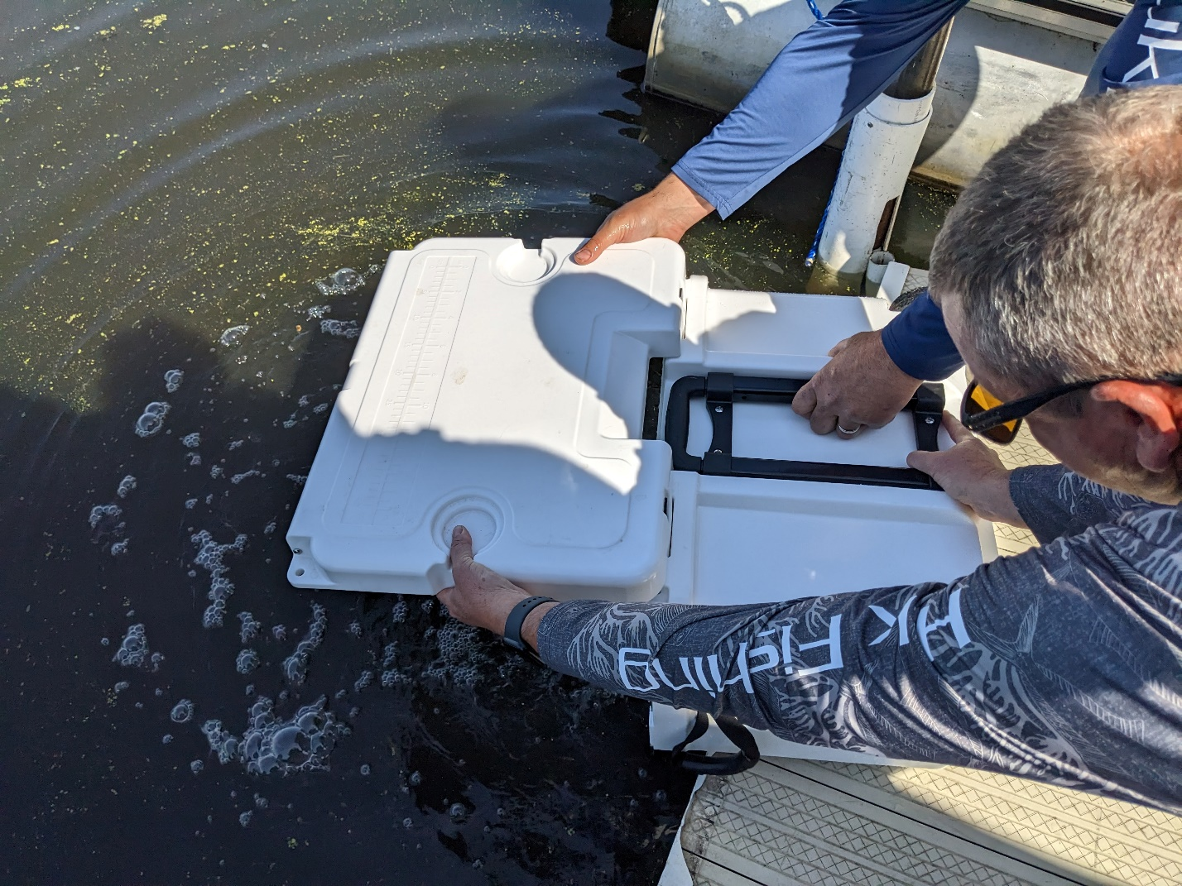
B
Bernie Sosinsky stocking fish

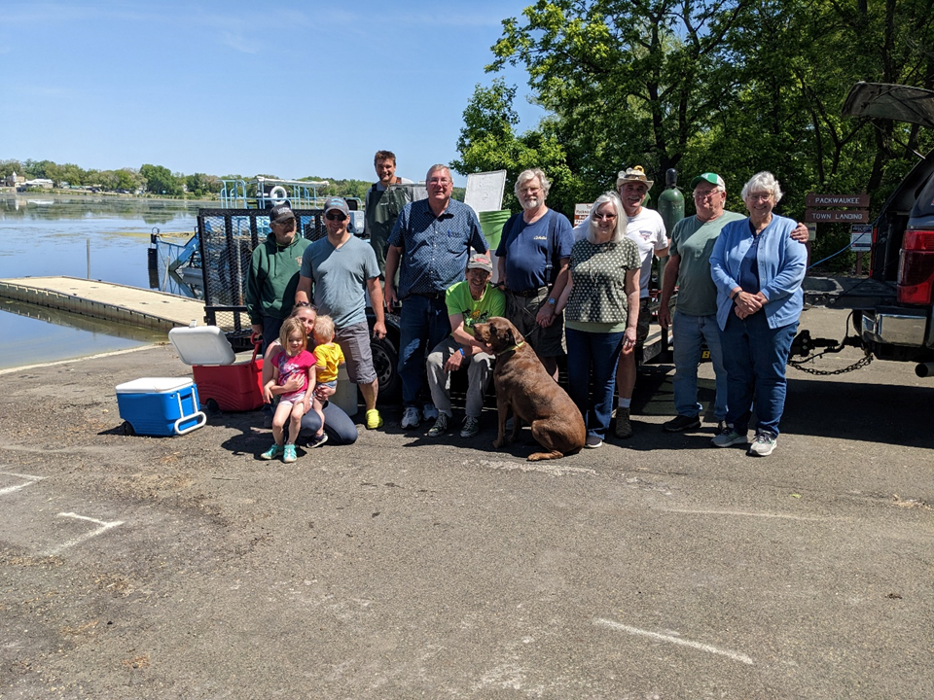
Freedom Landing: Frank Behling, Mike & family, Drake Schachtner, Paul Ratzburg, Clark Adams, Larry & Merry Haygood, Joe, Gary & Rose Kershaw

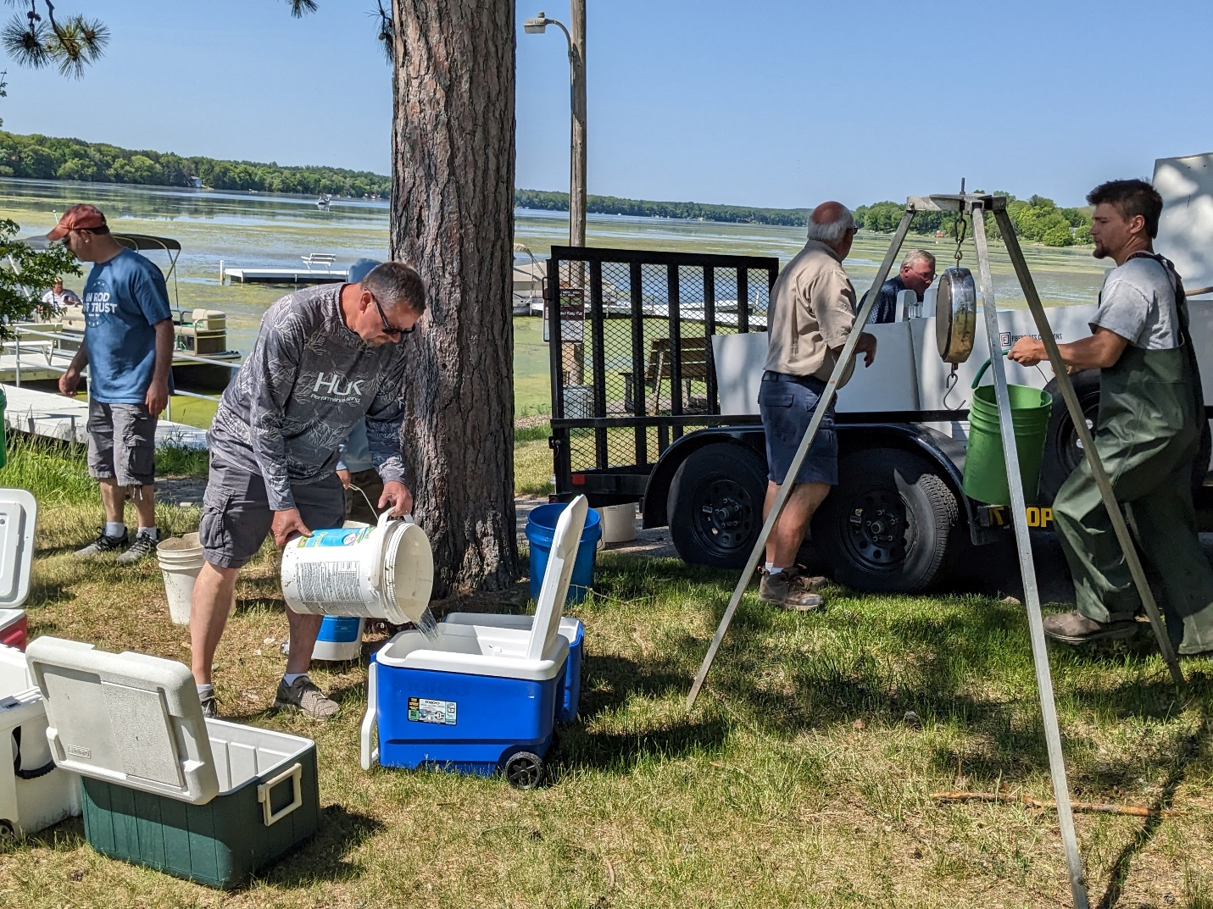
Calven Wood, Bernie Sosinsky, Gary Dounda, Drake Schachtner, loading fish for distribution into Buffalo Lake

